REDBIRD WRESTLING ACADEMY
(Weekly Technique Schedule)
Mondays and Wednesdays (3:00-4:30)

Week 1- (Starts May 25) Takedowns
Inside Step- Single, Double, Hi-C, Opposite Leg double, Fireman’s carry, Single Sweep-Cutback, Low angle,
Barrel roll. Elbow passes

Week 2 ( Starts May 30)- continue with Takedowns

Week 3- (Starts June 6) Short Offense
Front Headlock- Snap, Under hook, Head in hole, swim hip, cradle series
Crusher/cow catcher- Crusher limp arm, back hand, short drag, short side go behind

Week 4- ( Starts June 13)- Continue Short offense

Week 5- (Starts June 20)- Tilts and Turns
Cross Wrist series- Turk, Jump lift, Ball and chain, Dive Roll ball and Chain
Roll Thru Tilt, Chop tilt, Inside wrist tilt.

Week 6 – (Starts June 27)- Continue Tilts and Turns/ Top

Week 7- (Starts Wed. July 6. Off Monday July 4) Basic Top Pinning and Pin positions
Crossface series- Butcher, Hip Smash, Ankle Down, Butcher to Crusher, Rip Off, Crossface Cradle, Headlock pin position

Week 8- (Starts July 11)- Continue Top / Pins and Pin positions

Week 9 and 10 (Starts July 18)-- Advanced Top and Bottom
Arm Bar Series- Bar and wrist, Arm Bar Tilt, Stack, Bar and Hook, Double Arm Bar
Inside Wrist series- Gable, Tilt, Hammer Lock. Knee Slide Stand up, Slap arm, Switch series, Granby roll series

REDBIRD WRESTLING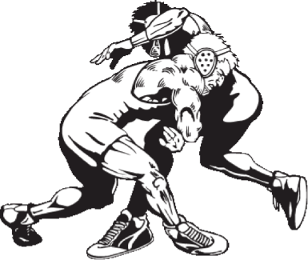ACADEMY
“Learn a SYSTEM of technique before the season even starts”
For ANYONE entering grade 6 through 12

WHERE: Alton High School (Wrestling room) 4500 sq. feet of mat space- Facing front of high school, drive around to RIGHT side of bldg, and enter there.
NO COST: This Academy is FREE to ALL

WHEN: Every MONDAY and WEDNESDAY: (3:00 – 4:30) STARTING MAY 25 THROUGH END OF JULY

*Bring a water bottle/ Water only

All sessions will be instructed by Alton High Head Coach Eric Roberson and Alton High Staff

Eric Roberson (As a Wrestler)

*3X IHSA State Qualifier (Roxana H.S.- 1984,86,87)
*IHSA All-State (4th place- 138 lbs- 1987)
*4X NCAA – II National Qualifier- SIUE
*2X NCAA- II All- American (SIUE- 142 lbs.- 5th in 1992, 4th in 1993)

As a Coach:

*Student Assistant at SIUE (1993)
*Head Coach, Roxana Middle School (1994)
*Asst. Coach, Roxana High School ((1995, 96)
*Head Coach, Alton Sr. High School (1997- Present)
*362-186 Dual Meet Record at Alton

Contact/ Questions:
Eric Roberson- 618-541-9135/ eroberson@altonschools.org

